Extraction from ORIC: The Myth of ν_{r} = 1 Resonant Extraction
Jim Ball September 2007

In its original design for ORIC, with a maximum field constant K_{B} = 75, the extraction of light ions was intended to be in a region where the value of ν_{r} is greater than unity, typically about 1.05. In later years, the field constant was raised to K_{B} ≅ 100 by increasing the main field current. The effect of running at these higher fields was to push the pole tips closer to saturation with the maximum of the radial field profile now moved inwards to coincide with typical extraction radii. Thus the extraction scheme used at ν_{r} ~ 1.05 was no longer applicable, and extraction close to ν_{r} =1 is now common for many of the high energy beams.
The general wisdom about extracting beam at ν_{r} =1 seems to be that one can use this resonance to drive oscillations that will provide the necessary orbit separation to facilitate effective extraction. The purpose of this note is to show that the ν_{r} =1 resonance has nothing to do with extraction of beam from a cyclotron at the point where the field profile goes through a maximum. It is, in fact, the falloff in the field that will be shown to effect the beam orbits, and this just coincidentally happens about the same place that ν_{r} =1.
We will start by addressing the question of how sensitive is acceleration in the cyclotron to the presence of the ν_{r} =1 resonance. In ORIC, as in any typical AVF cyclotron, the value of ν_{r} passes twice through a value of 1. The first of these is at relatively low radius where the field profile goes through a minimum at the transition between the falling “classical” region and the increasing field required to maintain isochronism. The second of these is at the outer radii where the field profile goes through a maximum. Since the first two terms in the equation for ν_{r} are 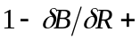..., the value of ν_{r} will be 1 in close proximity to the radius where 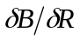 is zero, i.e., at a maximum or minimum in the profile.
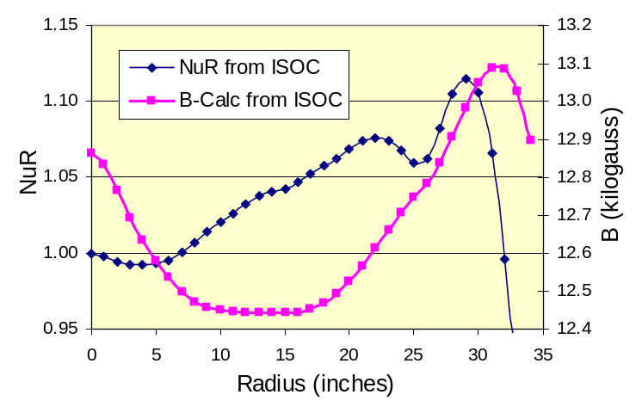
A typical profile for a proton beam is shown in the figure at right. This is a 50-MeV proton case, i.e., K_{B} = 50. (Note: This is the highest proton energy currently available from ORIC due to limitations on the upper rf frequency.)
For this energy protons the field profile reaches a maximum at about 31.5 inches, and ν_{r} goes to 1 just before 32 inches. However, since the extraction radius for this case is about 31.2 inches (maximum travel of the electrostatic deflector entrance for ORIC is 31.7 inches), the protons are deflected where ν_{r} is about 1.05.
In fact, for K_{B} = 50 we cannot get the entrance of the deflector out to the radius where ν_{r} =1. Thus we must by default use the technique for deflecting beams where ν_{r} > 1. This technique is not germane to the present discussion, and has been discussed elsewhere.
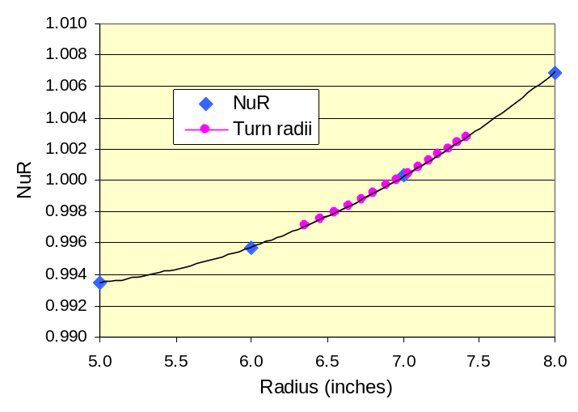
Before leaving this case, however, note that these orbits also traverse a region where ν_{r} =1 at around 7 inches. There is no indication that this transition produces any noticeably effect on the beam, even though these orbits are not precisely centered at this point, and are experiencing modest betatron oscillations. This then raises the question as to how many orbits must be traversing the ν_{r} =1 region, and how close is must be to ν_{r} =1, to produce a noticeable effect on the orbits. An expansion of the plot for ν_{r} in the region of 7 inches is shown at the right. Also plotted here are the average orbit radii for those orbits in the region of ν_{r} = 1.0 ± 0.003. At these two limits, the peak of a betatron oscillation would be moving about 1 degree per orbit. Thus having 15 turns within this proximity to ν_{r} =1 does not seem to present a significant source of orbit instability.
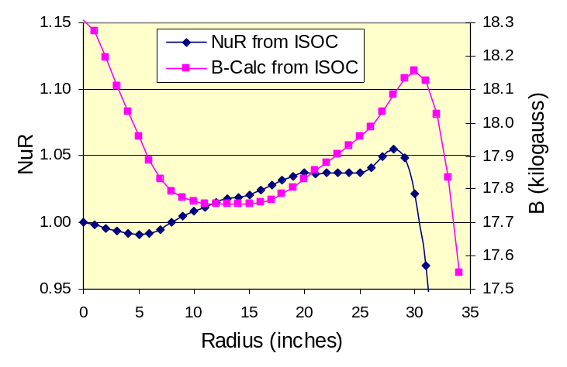
We now look at a case for 95-Mev alpha particles, i.e., for K_{B} = 95. The plot of ν_{r} and field profile for this case are shown at the right. Now at the higher K_{B} the maximum in the field profile has moved in to 30 inches, and ν_{r} =1 occurs at about 30.4 inches.
For this case, the extraction radius is about 30.6 inches, so here we do go past the point where ν_{r} =1. This then is a good example of extraction in the region where ν_{r} ≤ 1.
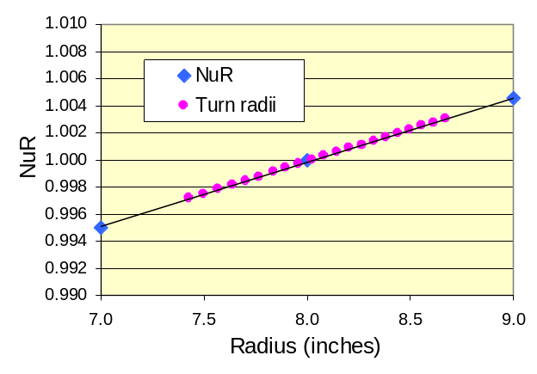
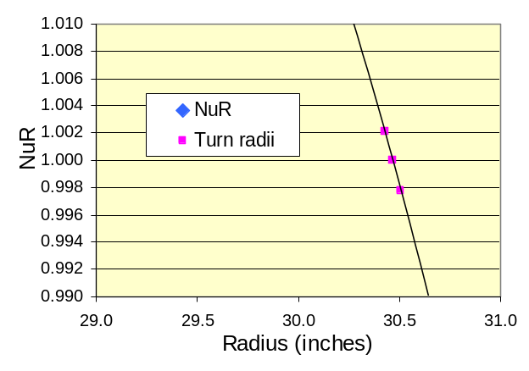
We can now look at the two regions where ν_{r} becomes 1. These two regions are plotted here, side-by-side on the same scale.
From the left-hand figure we see that there are 21 orbits in the ν_{r} = 1.0 ± 0.003 region around the transition at 8 inches. In this same region around the transition at 30½ inches there are only three orbits. Basically the beam goes through the transition at 30½ inches so fast that the ν_{r} =1 resonance has no opportunity to have any effect on the orbit properties. It is posited that this is true for any cyclotron of this type where the extraction is at or beyond ν_{r} = 1. That is, there is no opportunity to develop a resonance.
Instead, the orbits are affected strongly by sampling the sudden decrease in field that occurs at about this same radius. At the radii where the field profile begins to roll over, the orbit with that same average radius, because of the scalloped nature of its shape, during the maximum excursion is traversing through the lower field region. These maximum excursions occur over the pole tips where the saturation effects on the iron are having their biggest effect. The effect of the orbit traversing this “fall off” field, is to introduce radius of curvature perturbations that induce a precessing effect on the orbit paths. This precessional motion of the orbits introduces path separations. By careful application of a first harmonic perturbation to the field at these radii, these orbit separations can be controlled to facilitate beam extraction. An example of this is illustrated below using the 95-Mev alpha particle case just discussed.
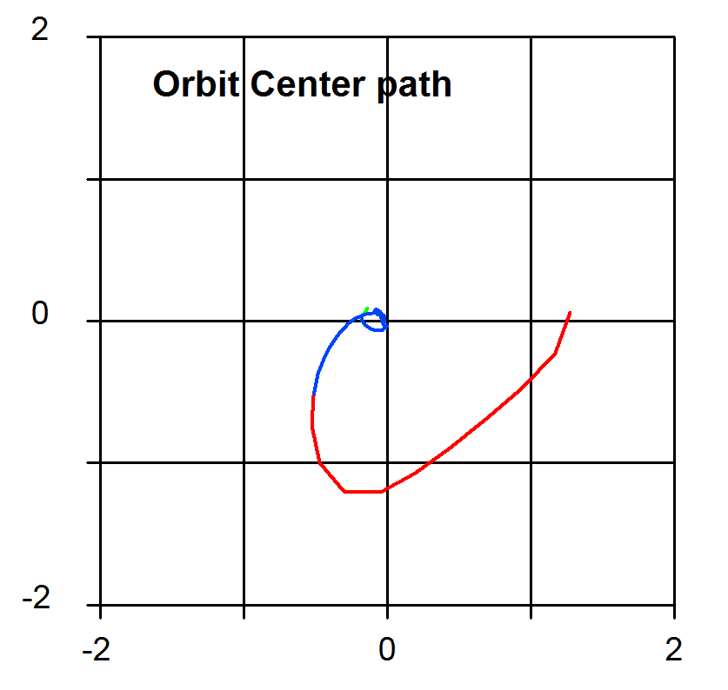
With no contribution to the field from the outer harmonic coils, the outermost orbits see an intrinsic first harmonic that causes a rather strong migration of the orbits out of the machine. This effect can be seen by looking at the position of the orbit centers during the acceleration cycle. Such a plot for the present case is shown at the right.
This plot is taken from the diagnostics program which is part of the ORIC orbit program package. The first ten turns are plotted in green (not visible on this plot, the last ten turns are plotted in red, and the intermediate turns are plotted in blue. The axis coordinates are in inches.
As can be seen here, even before the last ten turns, the path of the orbit center is beginning to move away from the cyclotron center and beginning the precessional motion that takes the orbit center out to over 1.2 inches from the machine center by the final turn.
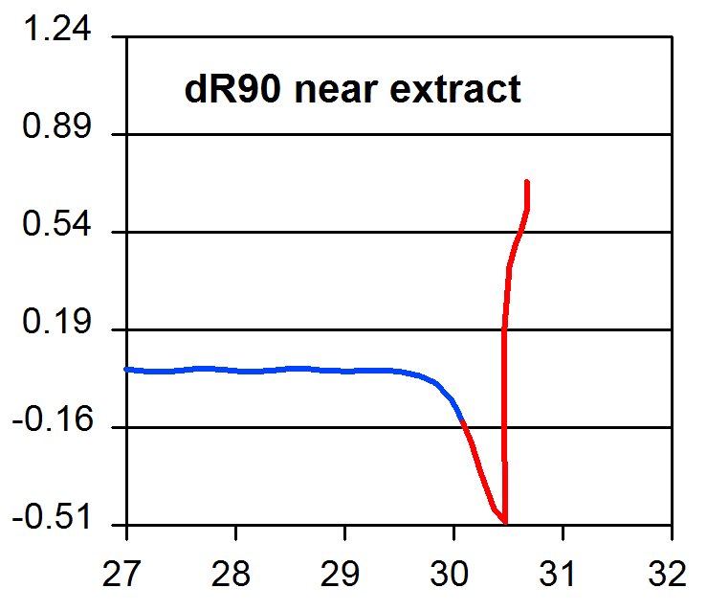
Although one might be tempted to try to extract this beam, the conditions near extraction are not very stable and far from ideal. The diagnostic plot of the separation between orbits for successive turns at an azimuth close to the entrance of the electrostatic deflector is shown in the plot at the right. Although the final orbits show an excellent separation, of the order of half an inch, the turn history shows an uncomfortable retrograde region. This is characteristic of the motion of orbits distorted enough by their traversal through the low field regions that before they reach the last few turns where they could be easily extracted, the earlier turns would intersect other components of the extraction system. This point can be better understood by examining the two orbit plots shown on the following page.
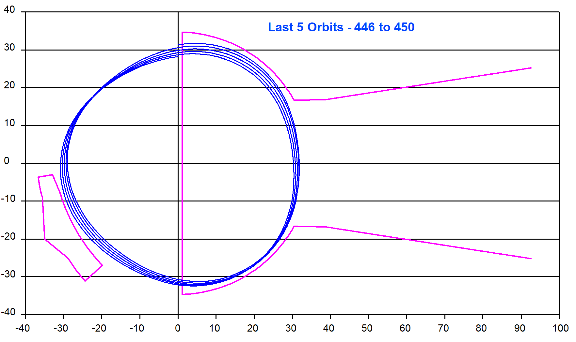
The first plot shows the orbit paths in the ORIC field for the last five orbits.

Here you see the good orbit separation at the upper exit edge of the dee where the beam is approaching the electrostatic deflector (the plot of orbit path terminates at 90 degrees, about 5 degrees before the entrance to the deflector). In addition to the dee outline, the position of the compensated iron “lower” channel is shown for reference. Although these orbits seem well enough behaved, if we now add the previous five orbits to this plot, we see the problem.
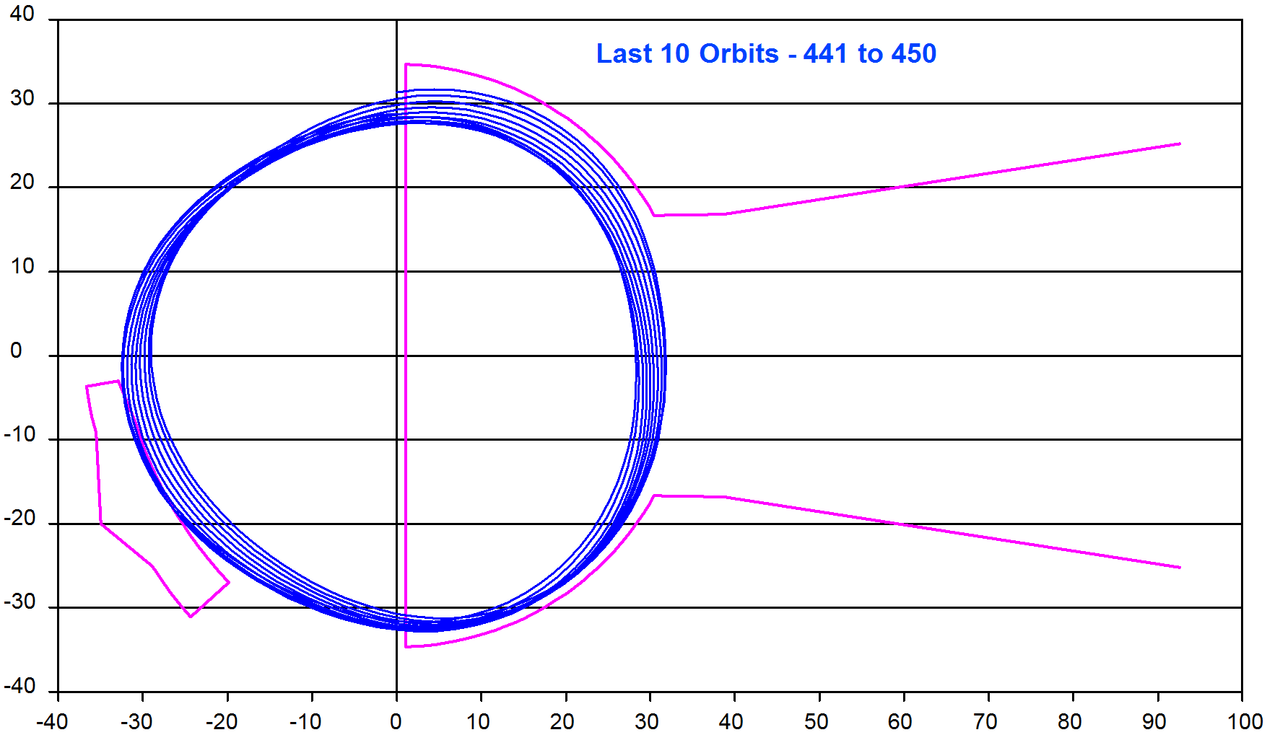

These orbits that were retrograde in the region of the deflector are seen to intercept the lower channel. Thus, the beam would be cut off at the point.
Thus in order to achieve orbits suitable for extraction, the amount of first harmonic present in the field needs to be adjusted by use of the harmonic coils in this region. This will be done using the two diagnostics discussed on the previous page as a guide.
With the use of the outermost harmonic coils to selectively adjust the amount of first harmonic and its azimuth, we can achieve orbits that exhibit the following diagnostic properties:
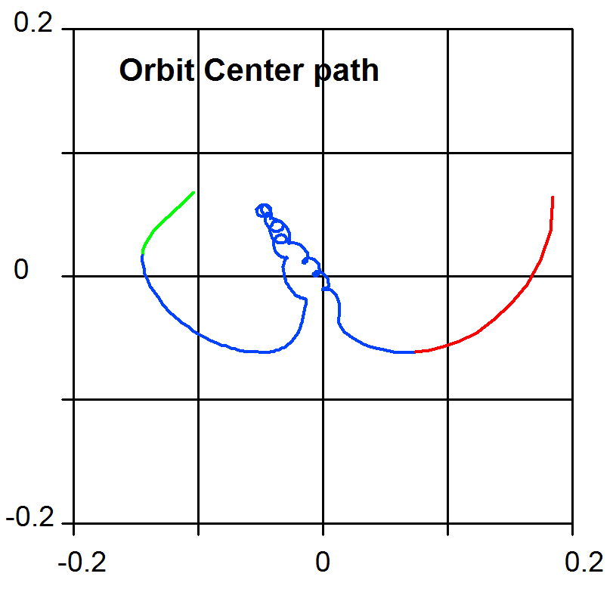
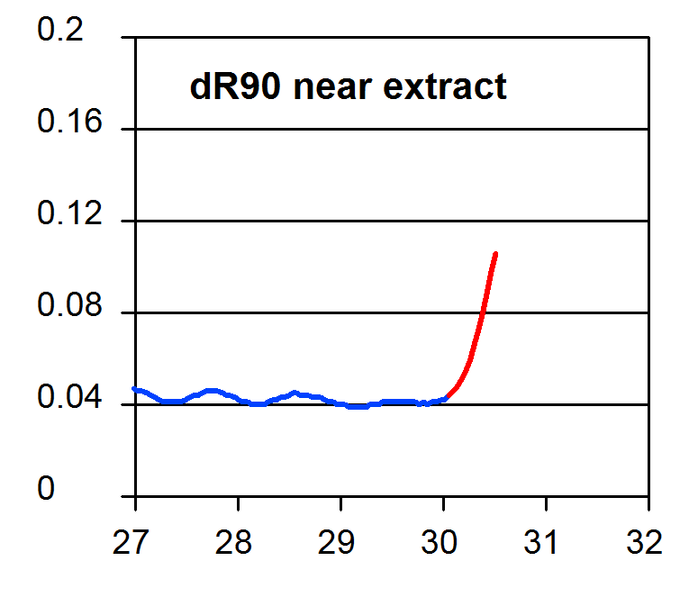

Note that the dimensions of the orbit center plot have been reduced by a factor of 10 from the first case shown above. At this magnification, the starting position can be seen to be slightly off center, but quickly migrates to the center of the machine. The last 10 orbits are just starting to begin their outwards precession with the direction chosen to produce an increased orbit separation at the deflector entrance. Although not the half inch seen previously, the separation achieved here of about 0.1 inch is quite adequate for passing over the thin septum of the deflector. For completeness, the plot of the last ten orbits is shown here. The orbits are seen to be well behaved, moving monotonically outward, and not striking any obstructions.
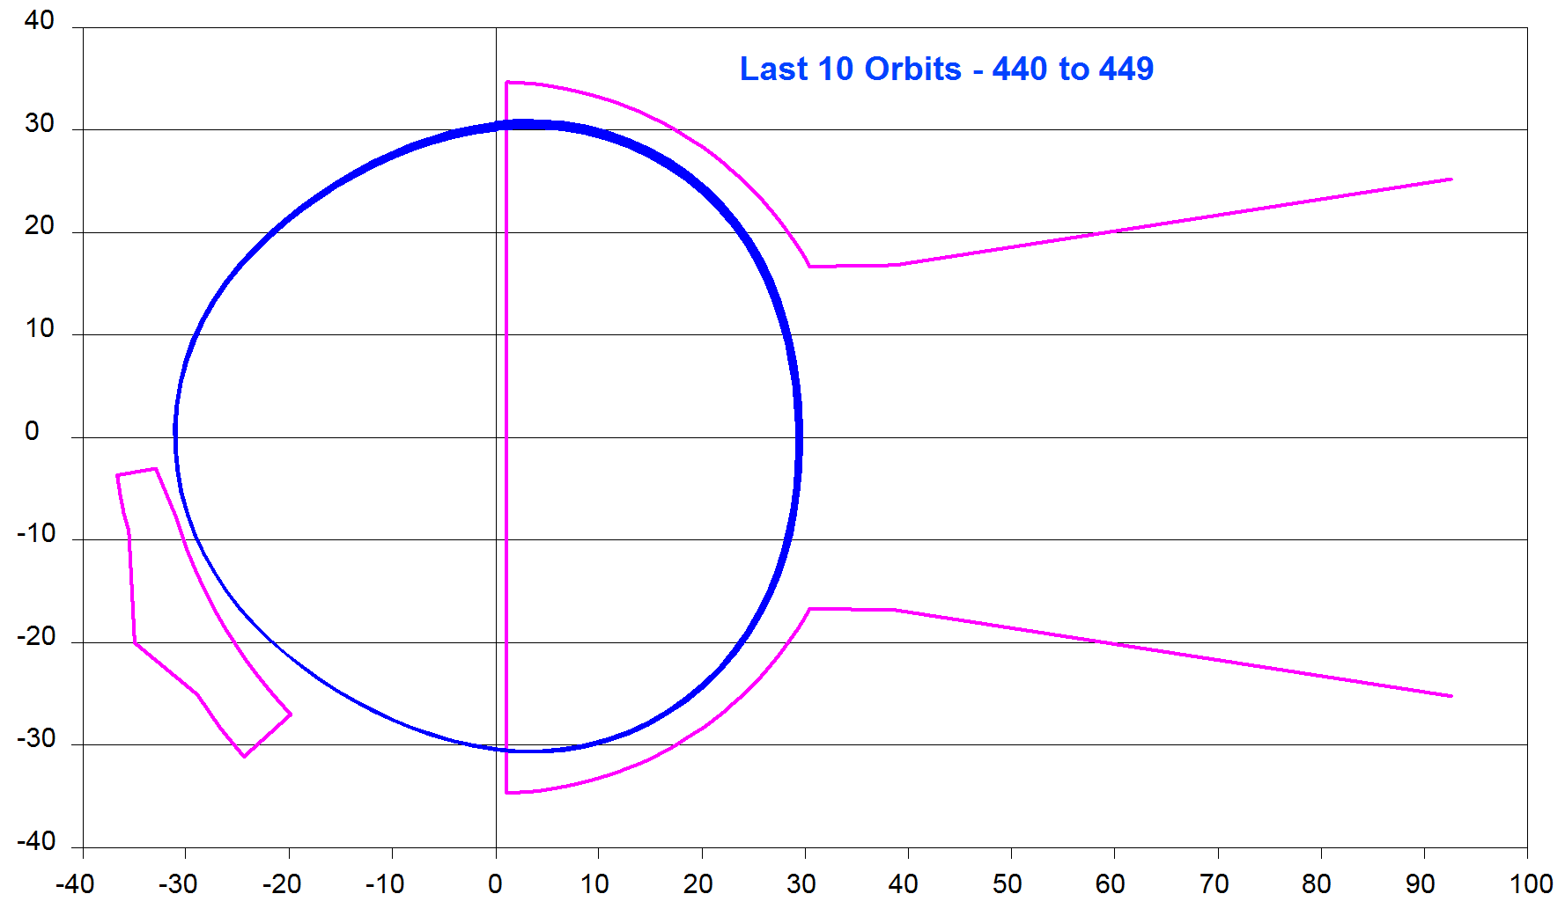

Thus, the conclusion is that the first harmonic has been used here, not to drive the ν_{r} =1 resonance, but to simply control the amount and direction of the orbit motion as it is sampling the falling regions of the field and starting to precess out of the cyclotron field.

Added Note: There is an interesting corollary from the above study that sets the maximum radius for acceleration of a given particle beam, and hence the maximum radius for positioning of the electrostatic deflector.
For 50 MeV protons, the field profile was seen to reach a maximum at 31.5 inches. This peak of the profile cannot be pushed to a larger radius, at present, because of the inoperable condition of trim coils 9 and 10. Since the field begins to fall off at 31.5 inches, the acceleration of stable orbits will not proceed much beyond this point. Hence, the present limit of 31.7 inches for the deflector entrance travel would not seem to present any major limit to the maximum proton energy attainable.
For the 95 MeV alpha particles at a higher field, the field profile reached a maximum at about 30 inches. In this case, the beam was extracted at 30.6 inches. This is probably about as far as one can expect to go beyond the point of field roll-off and still maintain well-behaved orbits.
Thus while one might expect to make slight energy gains for the proton beam by increasing the deflector travel to around 32 inches, there would be no applicability of this to any of the particle beams accelerated at higher fields. It would thus seem that any plans to increase the travel of the deflector radius should be postponed until such time as the new set of trim coils is installed.

R. J. Jones, et al., Electronuclear Division Annual Progress Report for 1963, ORNL-3630, pp. 38-46

